

Azure OpenAI – Step by Step Onboarding Guide
Version 1.0

April 2024

Revision History
Date | Version | Author | Change Description | Reviewed By
April 2024 | 1.0 | Ramandeep Kaur | Initial Draft | Kishan Zunjare

Table of Contents
Azure OpenAI – Step by Step Onboarding Guide 1
Revision History 2
1 Introduction 3
1.1 Azure OpenAI APIs 4
1.2 Out of scope 4
1.3 What you should know first 4
1.4 Audience 4
1.5 Acronyms, Abbreviations, Terms and Definitions 4
1.6 Assumptions 4
2 Step by Step Onboarding Guide 4
2.1 Navigate to the website 5
2.2 Default Credentials For Sign In 5
2.3 Home page after signing in 6
2.4 Navigate to the products tab 7
2.5 Products tab 7
2.6 Completions under Products 8
2.7 Subscribe to a Product 9
2.8 Approval Email 10
2.9 Access to API 11
2.10 Http Request 16
2.11 HTTP Response 17
3 FAQ 18
4 References 18

Introduction

Azure OpenAI APIs
Azure OpenAI Service provides REST API access to OpenAI's powerful language models like GPT and Embeddings model series. This document provides a comprehensive, step-by-step guide designed to assist developers in onboarding onto the platform for Azure OpenAI API consumption. This platform serves as a gateway, granting developers access to the Azure OpenAI APIs.
Main purpose of this document to make onboarding process straightforward and efficient.

Out of scope
This document is not intended to address other technical details or the installation details of any required components like Docker, Container etc.

What you should know first
- API Consumption
- Programming – Python, C# etc.

Audience
The intended audiences for this document are stakeholders, product development team, technical architect, operations team.

Acronyms, Abbreviations, Terms and Definitions
API | Application Programming Interface
AOAI | Azure OpenAI

Assumptions
We are assuming you are familiar with API consumption programmatically and have idea about Azure OpenAI Services.
- Understanding of Azure
- Azure OpenAI Service

Step by Step Onboarding Guide

Navigate to the website

- Azure API Management, a fully managed service by Microsoft, enables you to create, publish, and manage APIs within your applications. It provides a scalable and consistent approach for exposing APIs to external developers, partners, and customers.

- Click on the link given below:
https://apim-corp-ccoe-eastus2-dev.developer.azure-api.net/

- This will open the below window.

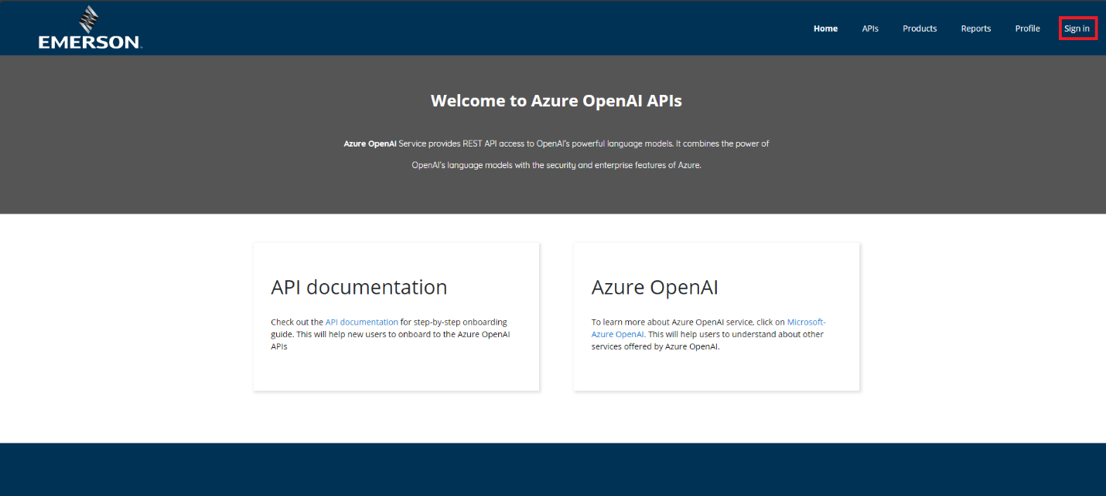

- Click on the Sign-in Button.

- You will be directed to the below window.

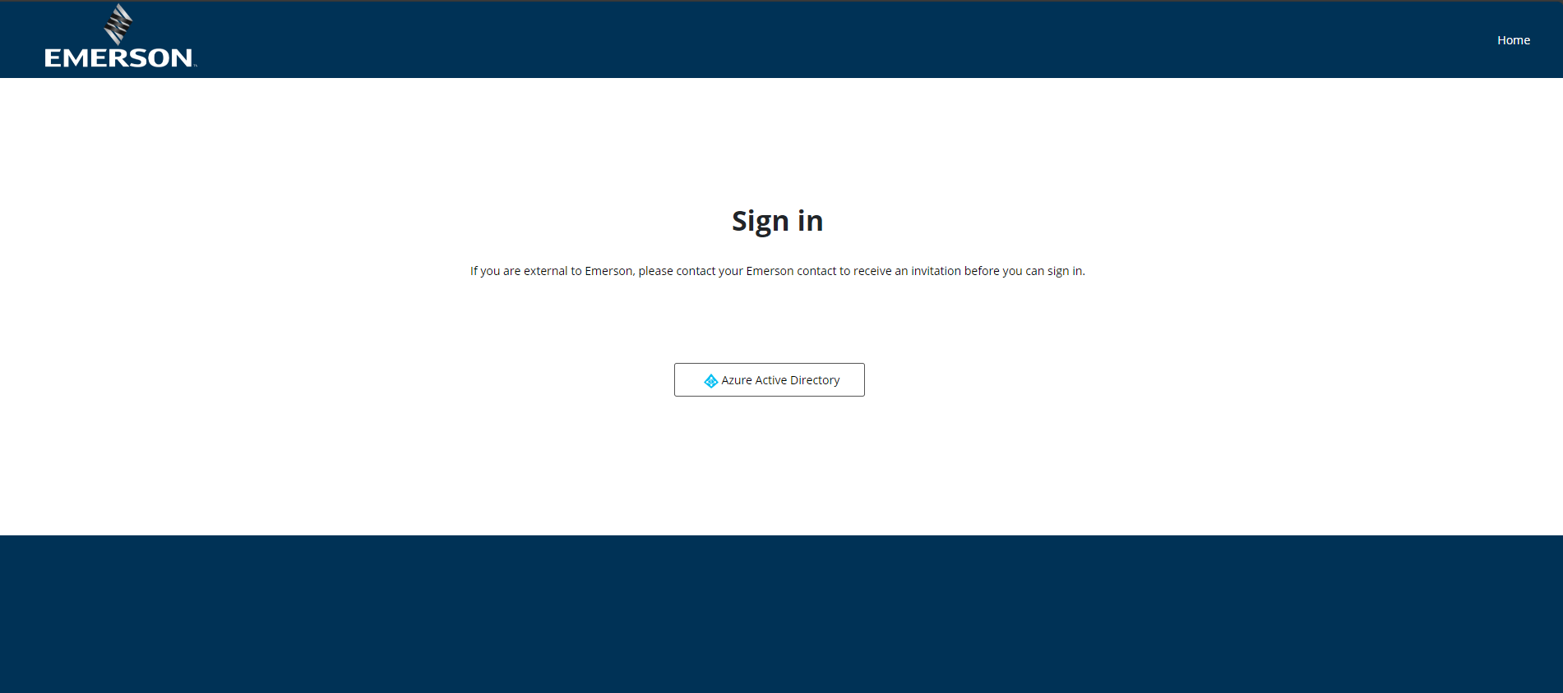

- Click on the “Azure Active Directory” Button.

- Azure Active Directory (Azure AD) provide single sign on integrated and enables secure access to the developer portal.

Default Credentials For Sign In

- After you click on the “Azure Active Directory,” a pop-up window will show up, asking for the default Emerson credentials.

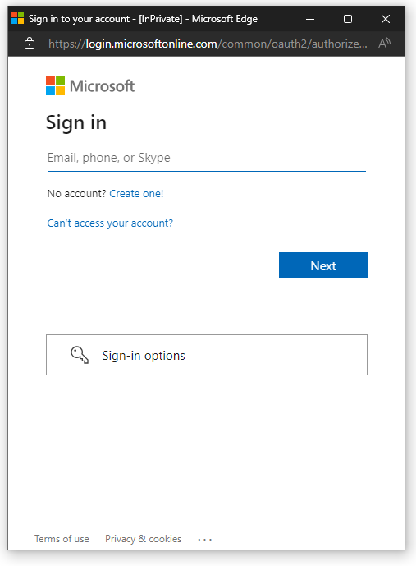

Home page after signing in

- After successful login (email and password), you will be directed to “Home page” as given below.

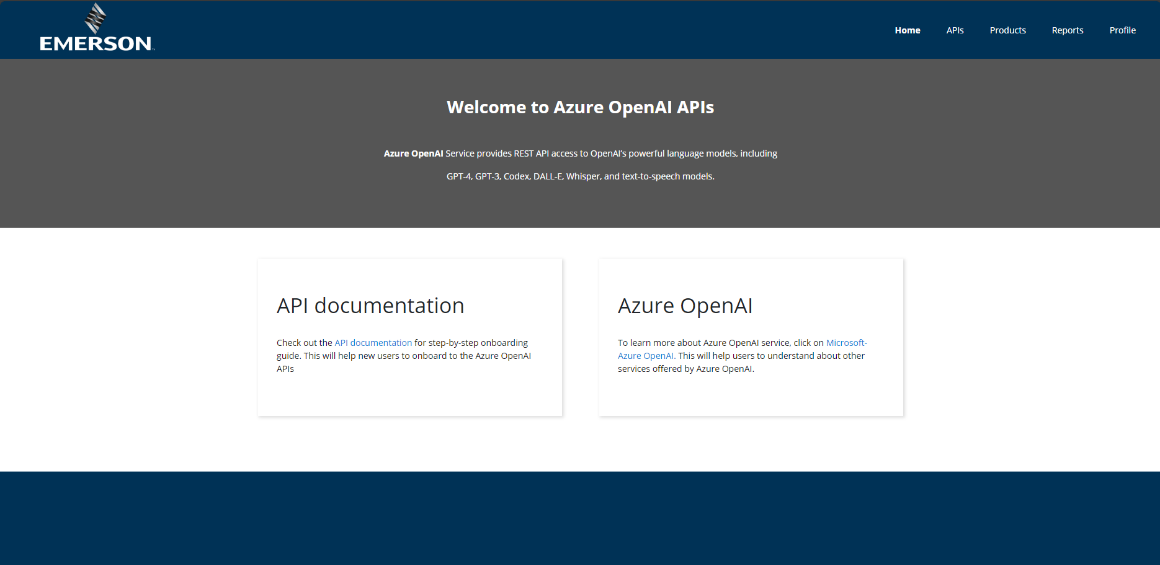

Navigate to the products tab

- Products tab plays a pivotal role in managing how APIs are surfaced to developers. A product in API Management contains one or more APIs.

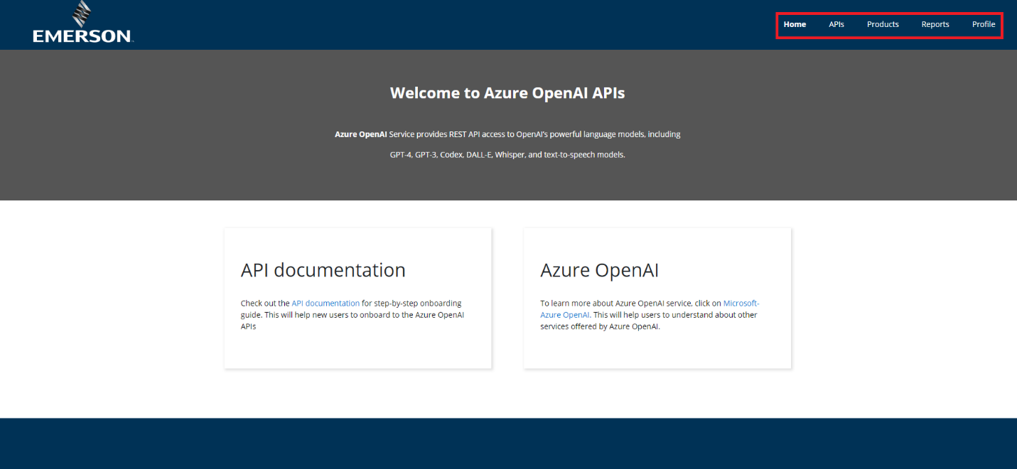

Products tab

- Click on the “Products” to subscribe to a product or view your already subscribed products.



- After clicking on the “Products”, you will be directed to below given page.

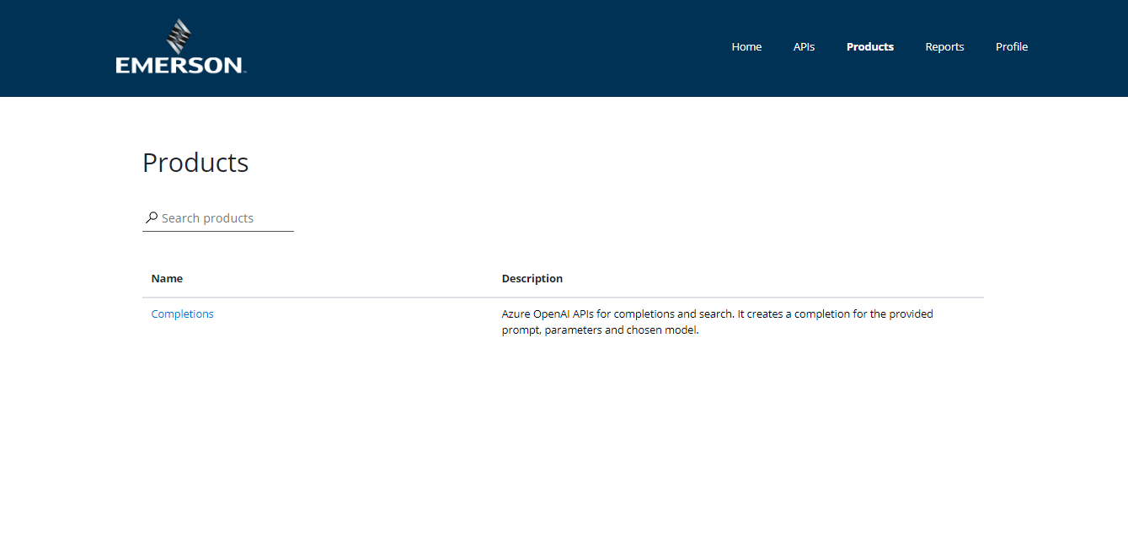

Completions under Products

- Click on the “Completions” under products.

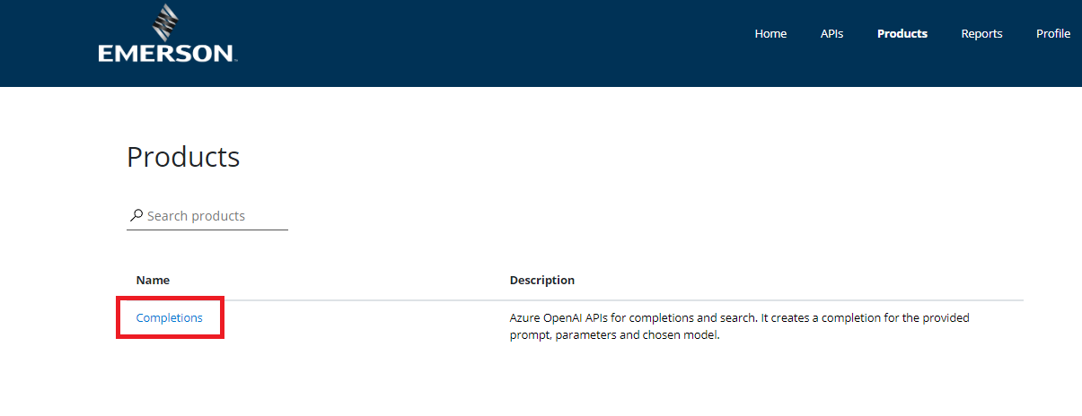

- After clicking on the “Completions” you will be directed to the page given below

- After locating the product, the subsequent action is to subscribe to the product associated with API.

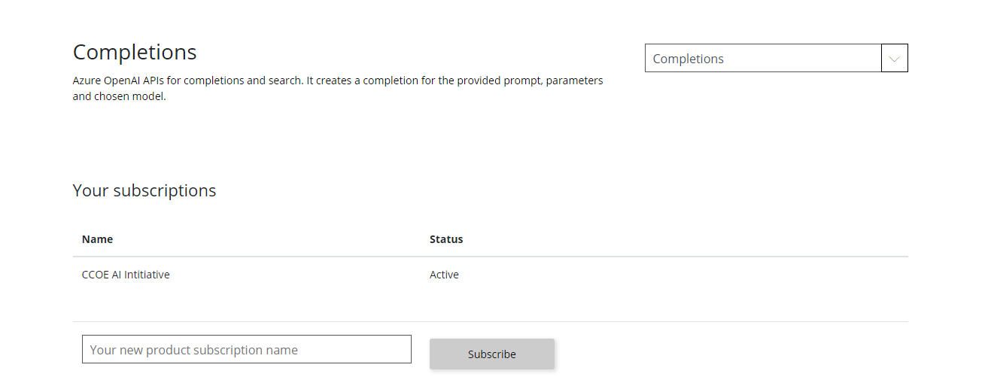

Subscribe to a Product

- Subscriptions provide a way for developers to access APIs securely using keys.

- To create a new product subscription name, click on the given box:
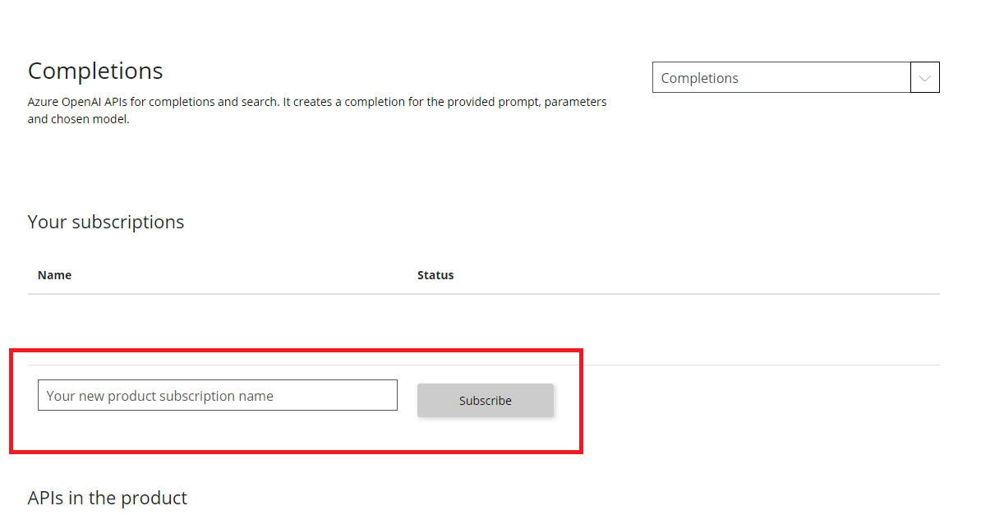

- Provide the desired subscription name and click on “Subscribe” button.
- This will give you access to the API and allow you to use it in your applications.

Naming Convention

To standardize the subscription naming with a consistent construct, the following naming standards can be established.
- Subscription naming conventions - “Business Group–Use Case Name-Environment”
- For example - “Flow Controls –AI Research-Dev” or “PWS–GenAIPilot-Prod”

Approval Email

- Once subscribed for the product, you will receive an email.

- There will be a delay while the subscription request is reviewed and approved by our team.

- Once request approved, you will receive an email. Check your email inbox for this message and follow the instructions to confirm your subscription.

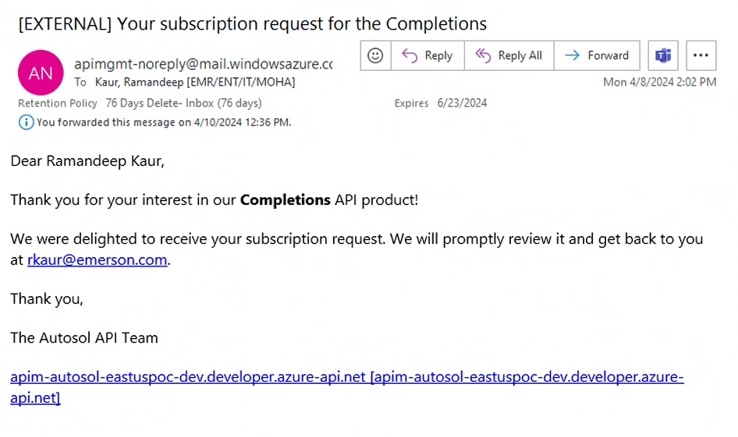

Access to API

- Upon subscription request approval, users have the opportunity within the portal that allows for assessing the API directly in the browser.

- The API tab provides a comprehensive view of all APIs hosted within your APIM instance.
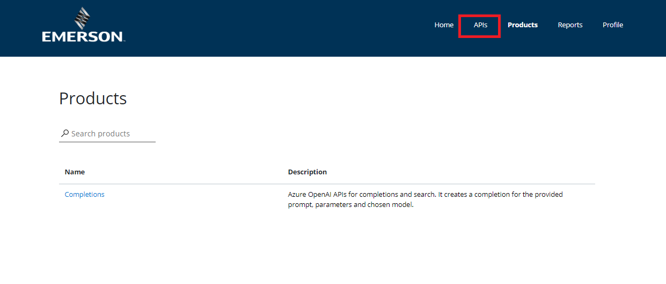

- After clicking on “API,” you will be directed to the page given below.
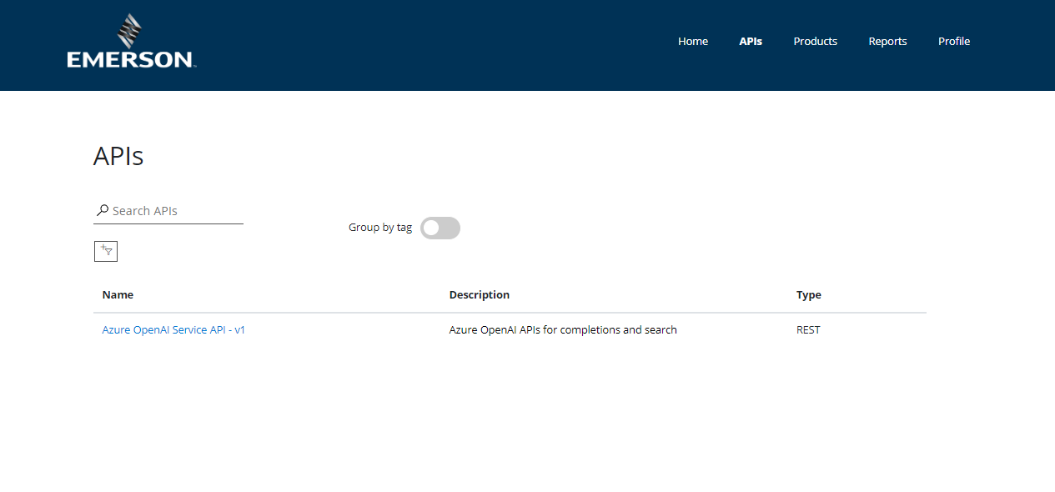

- Click on the given API link.
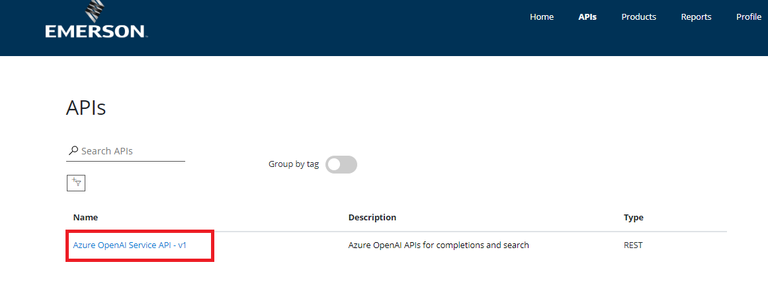

After clicking the API link, you will be directed to the page given below.

- Click on “Try” on that page.

- ‘Try’ enables you to interact with the API and send a HTTP request.

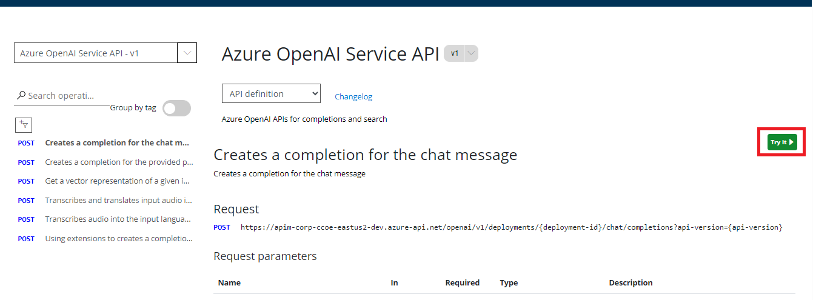

- After clicking try a side-window will appear as given below.

- The side window contains information like deployment id, API version, subscription key and other information.

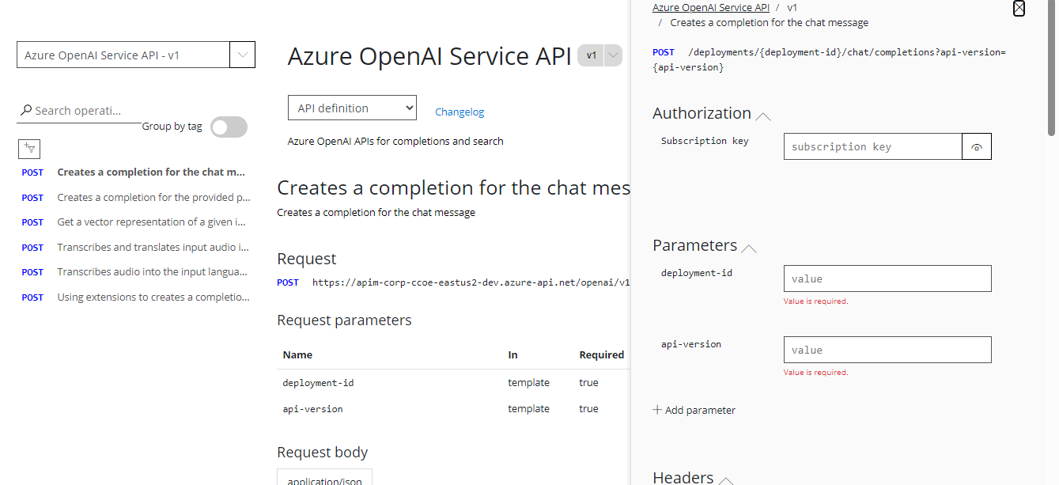

- Fill the empty dialogue boxes as given below:

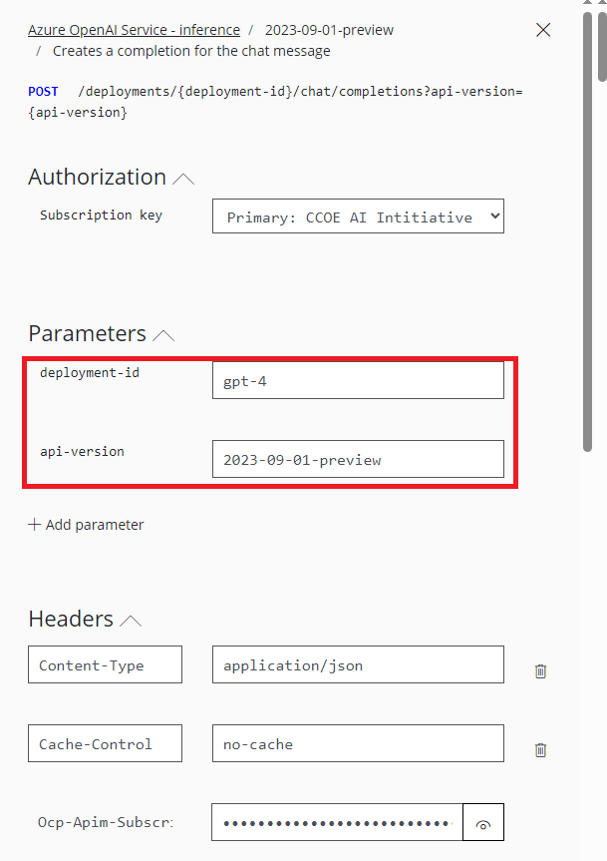

deployment-id: “gpt-35-turbo” or “gpt-4”

API-version: “2023-09-01-preview”

Http Request

- Scroll down the side window and you will see the HTTP request.

- HTTP request is used to interact with the services.

- HTTP Request sends request to the API.

- Click on the “Send” button to send the request.

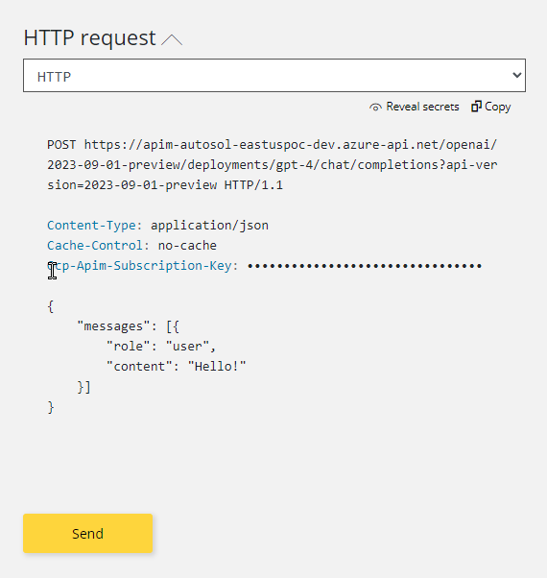

HTTP Response

- After clicking “Send,” you will get a HTTP Response.
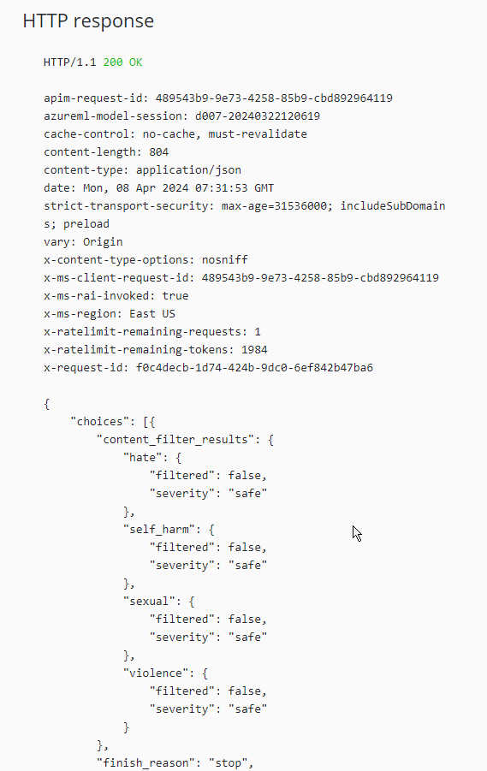

FAQ

- Does these API work outside Emerson Network?
Ans: These APIs only works within Emerson network only.

- Do I have to wait for the email confirmation to access the API?
Ans: Yes, email confirmations are sent after our team approves the requests.

- How long do I have to wait for the email confirmation?
Ans: You will receive an email confirmation as soon as your request have been approved by our team.

- Do I have to create a subscription to access the API?
Ans: Yes, you must create a subscription to access the API.

- How many subscription keys are created after creating the subscription?
Ans: A primary and a secondary subscription key is created.

References

Topic | Reference
Azure OpenAI Service documentation | https://learn.microsoft.com/en-us/azure/ai-services/openai/
Azure OpenAI Service REST API reference | https://learn.microsoft.com/en-us/azure/ai-services/openai/reference

